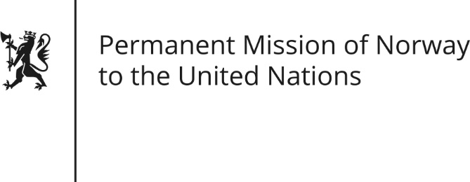

STATEMENT by Minister Counsellor Herborg F. Alvsaaker

Universal Periodic Review 27th Session. Review of Indonesia

3 May 2017

Check against delivery
Norway appreciates the excellent cooperation we have with Indonesia, including on human rights.

We commend Indonesia’s important achievements, including its juvenile justice reform, which is based on a restorative justice model.

While recognizing Indonesia’s efforts to build religious tolerance, we remain concerned by reports of discrimination of religious minorities. We recommend that Indonesia ensure all citizens can freely manifest their beliefs and that adherents of all faiths can fully enjoy their rights to health, education and other public services.

Norway also recommend that Indonesia review and repeal local bylaws that may limit rights guaranteed by the Constitution, especially as they relate to the rights of women, sexual minorities and religious minorities.

Human rights defenders have a strong standing in Indonesia, however Norway recommends that Indonesia take further steps to ensure a safe and enabling environment for all human rights defenders, including those representing the LGBT community and adat communities.
Lastly, Norway recommends a moratorium on executions with a view to abolish the death penalty.

